Metric Ranges Recheck
Jump Height /Unit - metres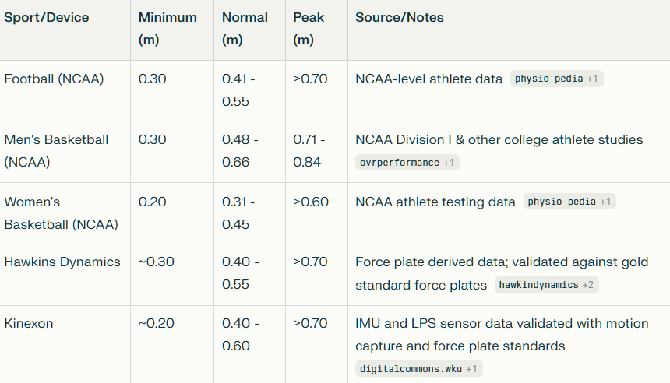
Peak Propulsive Power /Unit- Watts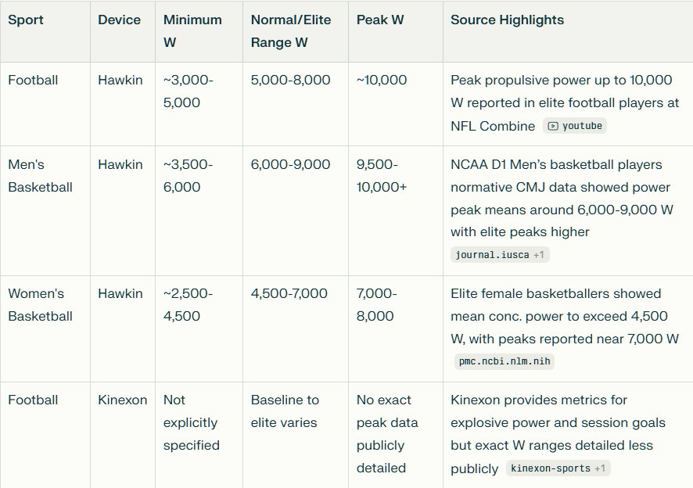
Reactive Strength Index – Modified (unit metre/sec)
